Aero-Chair ESP — Task 3 Prep: Gantt Charts & Critical Path Analysis
Oct 16, 2026

Overview
Task 3 (Plan) asks you to produce a programme of work and a supporting statement for manufacturing 100 sets of three Aero-Chair seats within 26 weeks and a £1,500,000 budget. You have 5 hours, no internet access, and the task is worth 18 marks.
Part | What it covers | Typical length
A — Programme of work | Key stages + approx. costs, resources/equipment, a critical path analysis showing duration and sequence | ~2 sides A4, digital/industry-recognised format
B — Supporting statement | Health & safety/risk, quality control, key stages, standards, specialist equipment, waste/environmental, assumptions | ~1000 words, separate document
These seven worksheets build the two skills examiners most often mark down — critical path analysis and Gantt charts — alongside the costing and written-statement skills Part A and B also need:
- Task 3 at a glance
- Breaking the project into activities
- Critical path analysis — the network diagram
- Critical path analysis — practice problems
- From network to Gantt chart
- Gantt chart practice
- Costing, resourcing and the supporting statement

Worksheet 1 — Task 3 at a Glance

Requirements recap
 | Part A — Programme of work | Part B — Supporting statement
Must include | Key stages + costs, resources/equipment, critical path analysis (duration & sequence) | H&S/risk assessment, quality control, key stages, standards, specialist equipment, waste/environmental, assumptions
Format | Digital software, industry-recognised format | Hard copy or saved file
Length | Typically 2 sides of A4 | Typically 1000 words
Separate documents? | Yes — keep A and B as two separate files

Conditions of assessment
- ☐ Working alone, under supervised conditions — no sharing or discussing with other candidates
- ☐ Access to word processing/spreadsheet software
- ☐ Access to your own Task 1 and Task 2 responses, for review only
- ☐ No internet access for this task
- ☐ Evidence handed in at the end of the session for secure storage

Time-budgeting — you have 5 hours (300 minutes)
Activity | Suggested time | Your plan
List activities, durations and dependencies | 30 min
Estimate costs and resources per stage | 45 min
Build the critical path network diagram | 45 min
Build the Gantt chart | 60 min
Write the supporting statement | 75 min
Review and check against requirements | 15 min
Total | 270 min (30 min buffer)

Self-audit checklist
- ☐ I can list every key stage with an approximate cost
- ☐ I have a resources/equipment list
- ☐ My critical path analysis clearly shows duration AND sequence
- ☐ My programme of work is in a digital, industry-recognised format (eg a Gantt chart)
- ☐ My supporting statement covers all six required areas
- ☐ Part A and Part B are saved as two separate files

Worksheet 2 — Breaking the Project into Activities
Before you can build a network diagram or a Gantt chart, you need a clean activity list: what has to happen, how long each stage takes, and — critically — what must finish before each stage can start (its dependency, or predecessor).

Practice: sequence the Aero-Chair manufacturing stages
The stages below are listed in a random order. For each one, estimate a realistic duration (within the 26-week / £1,500,000 / 100-sets limits) and identify which stage(s) must be complete before it can begin.
Activity | Description | Duration (weeks) | Preceding activity(ies)
 | Final design sign-off and CAD release
 | Order frame and fabric materials
 | Design and manufacture tooling/jigs
 | Machine and manufacture frame components
 | Cut and sew fabric covers
 | Assemble the seats
 | Quality inspection and sign-off
 | Pack and deliver

How to spot a true dependency
Ask: could this activity physically start if the one before it wasn't finished? If yes, they aren't really dependent — they could run in parallel. Manufacturing projects almost always have some activities running side by side (eg ordering fabric while tooling is being built) — don't force everything into one straight line.

Tips
- Durations should be realistic for the resource and budget available — check back against Worksheet 7 once you've costed things out.
- It's fine (and common) for one activity to have more than one predecessor, or to feed into more than one later activity.
- Keep activity names short and consistent — you'll reuse them in Worksheets 3–6.

Worksheet 3 — Critical Path Analysis: the Network Diagram

Why it matters
A critical path analysis (CPA) shows which activities, if delayed, would delay the whole project — and which have spare time (float) to move without affecting the overall finish date. This is exactly what the brief asks for: duration and sequence of activities.

The method
- Forward pass — work left to right to find the earliest an activity could start (EST) and finish (EFT): EST = 0 for the first activity; EST of a later activity = the latest EFT among everything that must finish first; EFT = EST + duration.
- Backward pass — work right to left to find the latest an activity could start (LST) and finish (LFT) without delaying the project: LFT of the last activity = its own EFT (the project duration); LST = LFT − duration; LFT of an earlier activity = the earliest LST among everything that depends on it.
- Total float = LST − EST. An activity with float = 0 is critical — any delay to it delays the whole project.
- The critical path is the unbroken chain of zero-float activities. Its total duration is the minimum time the project can take.

Worked example
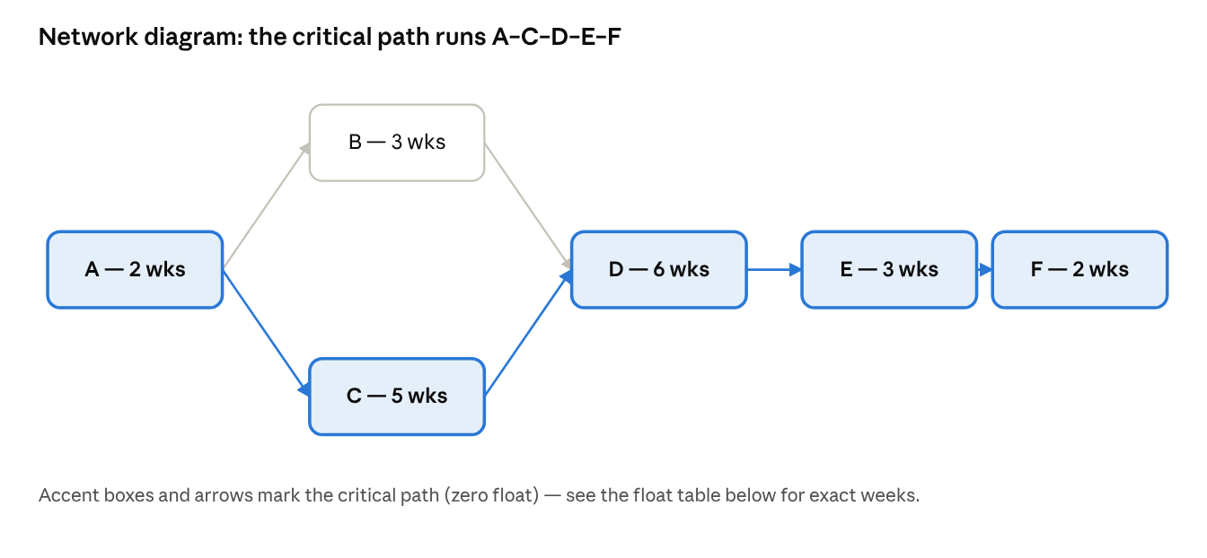
network diagram · 6 activities, critical path A-C-D-E-F
Activity | Duration | EST | EFT | LST | LFT | Float | Critical?
A — Finalise design | 2 | 0 | 2 | 0 | 2 | 0 | Yes
B — Order materials | 3 | 2 | 5 | 4 | 7 | 2 | No
C — Manufacture tooling | 5 | 2 | 7 | 2 | 7 | 0 | Yes
D — Manufacture components | 6 | 7 | 13 | 7 | 13 | 0 | Yes
E — Assembly | 3 | 13 | 16 | 13 | 16 | 0 | Yes
F — Quality testing | 2 | 16 | 18 | 16 | 18 | 0 | Yes
Critical path: A–C–D–E–F = 18 weeks. B has 2 weeks of float — it could start up to 2 weeks late without delaying the project.

Blank template — reuse this for any network you analyse
Activity | Duration | EST | EFT | LST | LFT | Float | Critical?

Worksheet 4 — Critical Path Analysis: Practice Problems
Work through both problems on paper or in a spreadsheet. Do the forward pass, then the backward pass, then float, then state the critical path. Answers are in the appendix — mark your own work honestly before checking.

Problem 1 — five activities
A small sub-assembly has five activities.
Activity | Description | Duration (weeks) | Predecessors
P | Source raw materials | 3 | —
Q | Draft technical drawings | 4 | —
R | Machine components | 5 | P
S | Assemble sub-unit | 2 | Q, R
T | Inspect and test | 2 | S
Blank working table — fill in every column:
Activity | Duration | EST | EFT | LST | LFT | Float | Critical?
P
Q
R
S
T
Critical path: _______________________ Minimum duration: _______ weeks

Problem 2 — eight activities
A larger work package has eight activities, numbered A1–A8.
Activity | Description | Duration (weeks) | Predecessors
A1 | Finalise specification | 2 | —
A2 | Order materials | 3 | A1
A3 | Book facilities and equipment | 2 | A1
A4 | Manufacture components | 6 | A2
A5 | Assemble | 4 | A3, A4
A6 | Quality checks on sub-assemblies | 3 | A3
A7 | Final inspection | 2 | A5
A8 | Pack and release | 1 | A7
Blank working table:
Activity | Duration | EST | EFT | LST | LFT | Float | Critical?
A1
A2
A3
A4
A5
A6
A7
A8
Critical path: _______________________ Minimum duration: _______ weeks
Check: does your critical path form one continuous chain from the first activity to the last, with every float value on it equal to zero? If not, re-check your backward pass before moving on.

Worksheet 5 — From Network to Gantt Chart

Why use both
A network diagram shows the logic: which activities must finish before others can start, and where the critical path sits. It does not show when, on a calendar, anything happens. A Gantt chart converts that logic into a timeline — a bar for every activity, positioned against weeks (or days), so a planner, a client or an assessor can see the whole programme of work at a glance. Task 3 Part A asks for exactly this combination: a programme of work in an industry-recognised digital format, with the critical path identifiable.

How to build a Gantt chart from your network
- List every activity down the left-hand side, in a sensible order (normally the order they start).
- Create a time axis along the top, in weeks, long enough to cover the full project duration.
- For each activity, draw a bar starting at its EST and ending at its EFT, using the forward-pass figures you already calculated.
- Give each bar a length matching its duration — check it visually against the axis.
- Highlight the critical-path activities in a different colour or fill, so the reader can trace the critical path as one continuous run of bars.
- Mark any float as a thinner or dashed extension after a non-critical bar, reaching out to its latest finish time (LFT), so the reader can see how much slack each activity has.
- Add a title, a key/legend explaining the colours, and (if useful) milestone markers for major handover points.

Worked example
The Gantt chart below is built from the six-activity worked example in Worksheet 3 (A–F, critical path A–C–D–E–F, 18 weeks). Compare the bar positions against the EST/EFT/LST/LFT table you completed there.
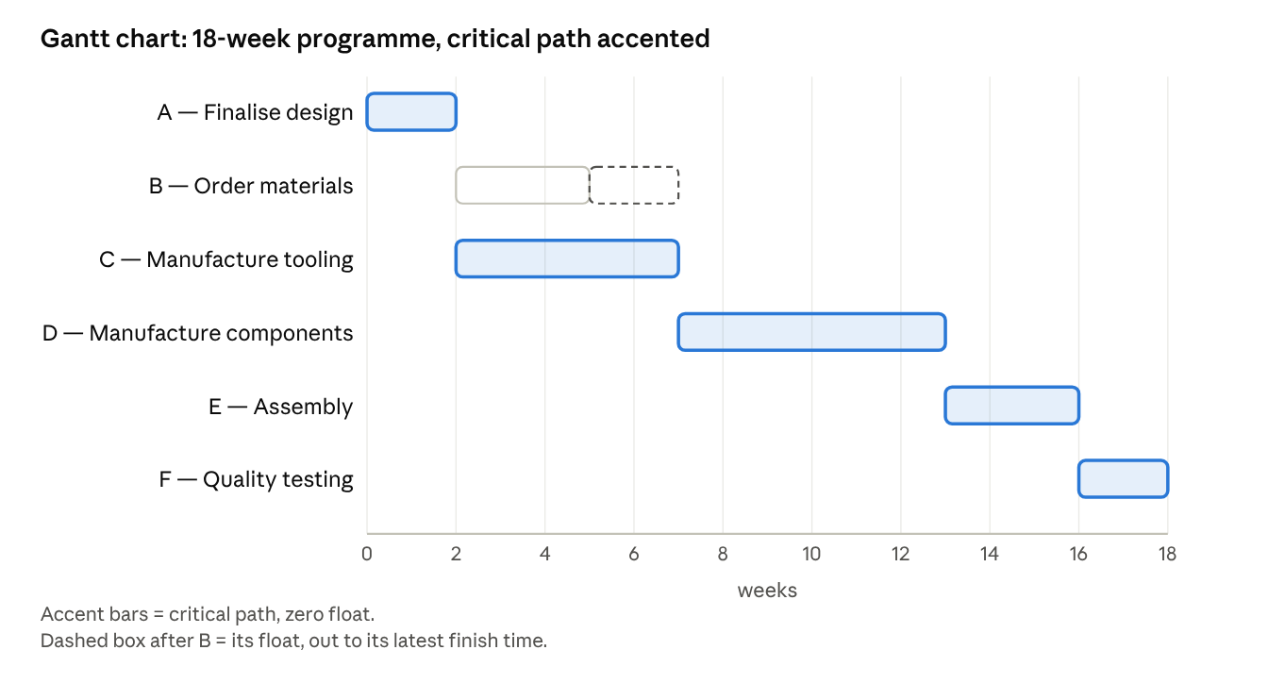
Gantt chart · 6 activities across 18 weeks, critical path accented
Notice how the critical-path bars (A, C, D, E, F) run as one continuous chain with no gaps between them — that visual continuity is exactly what "zero float" looks like on a timeline. B's bar, by contrast, finishes early and could slide up to two weeks later without delaying the project; that gap is its float, shown as the dashed extension.

Worksheet 6 — Gantt Chart Practice
In the real assessment you will have no internet access, but you will have standard office software. Building your Gantt chart in a spreadsheet (Excel, Google Sheets, or similar) is the quickest route to something that looks professional and counts as an "industry-recognised digital format."

The stacked-bar method in a spreadsheet
- Create a table with one row per activity, with columns for Activity, Start week, Duration.
- Insert a stacked bar chart using Start week as the first (invisible) series and Duration as the second (visible) series — the invisible series pushes each bar along to its correct starting point.
- Format the Start-week series with no fill, so only the Duration bars show.
- Recolour the bars for your critical-path activities so they stand out from the rest.
- Add a chart title, axis titles, and a legend explaining the colour coding.
- Reverse the category (activity) axis if your activities are listing bottom-to-top instead of top-to-bottom.

Now build your own
Using your completed answers from Worksheet 4:
- Build a Gantt chart for Problem 1 (activities P, Q, R, S, T — 12-week project).
- Build a Gantt chart for Problem 2 (activities A1–A8 — 16-week project).
For each chart, use the EST/EFT figures from your own working, not the duration column alone — a bar's position matters as much as its length.

Quality checklist
Before you consider a Gantt chart finished, check it has:
- ☐ A clear title stating what the chart shows
- ☐ A labelled time axis (weeks), evenly scaled
- ☐ Every activity listed, in a sensible order
- ☐ Bars positioned at the correct start time and sized to the correct duration
- ☐ Critical-path activities visually distinct from the rest
- ☐ A legend or key explaining any colour coding
- ☐ Any key milestones or handover points marked
- ☐ Saved in a format you could open and present on the day (e.g. .xlsx, .pptx, or exported as an image/PDF)

Worksheet 7 — Costing, Resourcing and the Supporting Statement
Part A of Task 3 is not only a schedule — it must show costs and resources too, within the Aero-Chair constraints: 100 sets of 3 seats, 26 weeks, and a maximum budget of £1,500,000 (£15,000 per set). Part B is a ~1000-word supporting statement explaining and justifying your plan.

Costing table template
Stage | Duration | Resources / equipment needed | Approx. cost | Running total
Check your running total against £1,500,000 after every row — going over budget partway through is easy to miss if you only total at the end.

Supporting statement planning grid
Use this grid to gather your points before you write continuous prose. Each row should become a short paragraph in your final statement.
Area | Questions to answer
Health & safety / risk | What are the main hazards in this process? How will you control them?
Quality control | How will you check that each set of seats meets the required standard? At which stages?
Key stages | Which stages matter most to get right, and why?
Standards | Which industry or regulatory standards apply to aircraft seating?
Specialist equipment | What tooling, machinery or testing equipment does this plan rely on?
Waste & environmental impact | What waste does this process generate, and how will you minimise or manage it?
Assumptions | What have you assumed about materials, staffing or timescales that the brief does not state directly?
Link to your critical path: the activities on your critical path carry the greatest schedule risk — a delay to any one of them delays the whole project. It is worth naming this explicitly in your health & safety / risk paragraph, and saying what you would do if a critical activity overran.

Task 3 submission self-audit
- ☐ Programme of work is in a digital, industry-recognised format (e.g. Gantt chart)
- ☐ Critical path is identifiable on the programme
- ☐ Durations and sequencing are shown for every key stage
- ☐ Resources and equipment are listed against each stage
- ☐ Costs are shown and stay within £1,500,000
- ☐ Part A fits in roughly two sides of A4
- ☐ Supporting statement covers all seven areas above
- ☐ Supporting statement is approximately 1000 words
- ☐ Spelling, punctuation and grammar checked
- ☐ Work is saved and backed up before the session ends

Answers — Worksheet 4 (for checking only)
Don't look here until you've worked through both problems yourself. Mark your own working honestly — if your float values don't match, re-check your backward pass before reading further.

Problem 1
Activity | Duration | EST | EFT | LST | LFT | Float | Critical?
P | 3 | 0 | 3 | 0 | 3 | 0 | Yes
Q | 4 | 0 | 4 | 2 | 6 | 2 | No
R | 5 | 3 | 8 | 3 | 8 | 0 | Yes
S | 2 | 8 | 10 | 8 | 10 | 0 | Yes
T | 2 | 10 | 12 | 10 | 12 | 0 | Yes
Critical path: P – R – S – T. Minimum duration: 12 weeks. Q has 2 weeks of float — it can start up to 2 weeks late without delaying the project, because S cannot start until both Q and R are finished, and R finishes later (week 8 vs Q's week 4).

Problem 2
Activity | Duration | EST | EFT | LST | LFT | Float | Critical?
A1 | 2 | 0 | 2 | 0 | 2 | 0 | Yes
A2 | 3 | 2 | 5 | 2 | 5 | 0 | Yes
A3 | 2 | 2 | 4 | 5 | 7 | 3 | No
A4 | 6 | 5 | 11 | 5 | 11 | 0 | Yes
A5 | 4 | 11 | 15 | 11 | 15 | 0 | Yes
A6 | 3 | 4 | 7 | 8 | 11 | 4 | No
A7 | 2 | 15 | 17 | 15 | 17 | 0 | Yes
A8 | 1 | 17 | 18 | 17 | 18 | 0 | Yes
Critical path: A1 – A2 – A4 – A5 – A7 – A8. Minimum duration: 18 weeks.
Working notes: A5 needs both A3 and A4 finished, and A4 finishes later (week 11 vs A3's week 4), so A3's float is driven by that gap (11 − 4 = 3 weeks less the margin already used — LST for A3 is 7, giving float 7 − 4 = 3). A6 feeds into A7, which also needs A5; A5 finishes later (week 15 vs A6's week 7), so A6's LFT is pulled back to 11, giving float 11 − 7 = 4 weeks.

A note for tutors
If students consistently get Problem 2's float values wrong, the likely cause is treating A3 and A6 as if they only need to satisfy their own immediate successor's earliest requirement, rather than tracing the backward pass through to the end of the project. It's worth working one converging-path example together on the board before setting Worksheet 4 as independent practice.

